**Project Title: Plasma Donor Application**

**Team Members:**

714019104076 – Priyadharshini M

714019104086 – Rukash D G

714019104097 – Shobika T S

714019104098 – Sineka A S

**Abstract:**

Plasma Donor Application is aimed to developing a Plasma Donor information via online. The numbers of blood donor are very less when compared with other countries. In our project, the consumer wants to make request for blood and soon the donor will be asked to enter an individual's personal details. The system that is designed to store, process, retrieve and analyse information concerned with the administrative and inventory management within a blood bank. At the emergency time of blood needed, we can check for blood donor nearby using GPS. The admin is the main authority who can do addition, deletion and modification if it’s required. Once we can’t able to reach the accepted donor and soon the application will send a request to another donor which will be represented in queue data structure. If the donor accepts the request, then a one-time password (OTP) will be sent to the donor for verification. Aim is to provide transparency in this field, make the process of obtaining blood from a blood bank hassle free and corruption free and make the system of Plasma Donor Application effective. Plasma donation app provide the list of donors in your city/area. Once the donor donates the blood it will automatically remove the donor details for next three months. This application takes care of different modules and their associated reports which are produced as per the applicable strategies and standards that are put forwarded by the administrative staff.  Application is developed in a manner that is easily manageable, time saving and relieving one from manual works. The requirement of the blood has to be requested and we supply the information of the donor. The donors can update their status whether they are available or not.

**Literature Survey of the Plasma Donor Application:**

**[1]** In “Android blood bank” by prof. Snigdha proposed an application for blood donor. In that application the donor can find the exact path by using GPS (Global Positioning System). The detail of blood donors will be saved private data and confidential data are only viewed by the administrator. They have methodologies like PHP, MY SQL, Android.

**[2]** In “MBB: A Life Saving Application” by Narendra Gupta has proposed a method to create a website with android application. In this application, it has been proposed that the donor is tracked by Geographic Information System (GIS). The purpose of their website is used to update their current system where data can only be viewed by authorized user. They contain two dev-ice type:

1)An android phone with android OS

2) A computer for website and database which is used to store

the information about the donor.

**[3]** In “Android Based Health Application in Cloud Computing for Blood Bank” by Sayali Dhond has proposed android based application for blood donor, in which the donor’s information are stored in cloud. They user should request blood on the cloud and the information are sent to nearby hospital or blood donor who are register on cloud.

**[4]** In “The Optimization of Blood Donor Information and Management System bt Technopedia” by P. Priya has proposed a method of creating website with android application in which the blood donor can easily available within the required time. The donor who are nearby location are easily tracked by GIS. In this application the website is to update the information of donor who have already given blood in various hospital. While comparing to manual system, computer-based information system is time consuming, laborious.

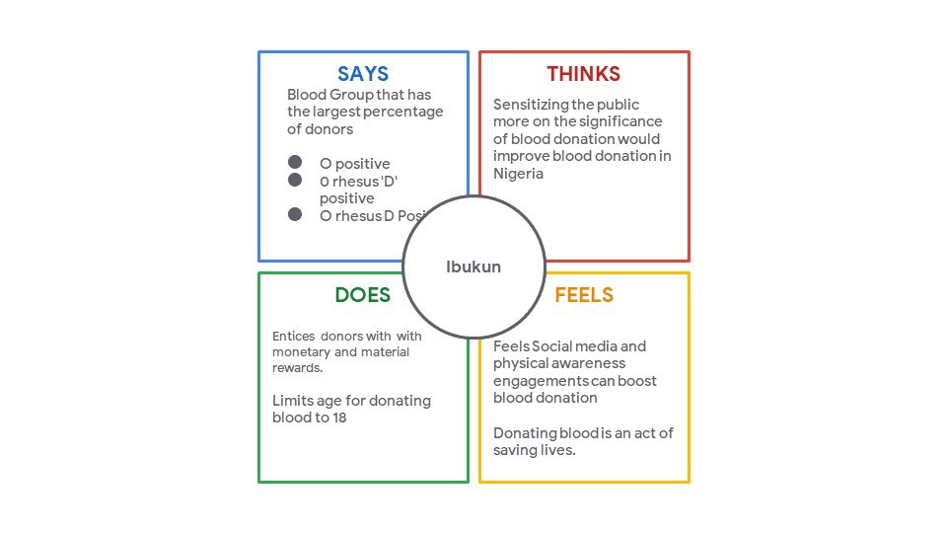**Empathy Map for Plasma Donor Application:**

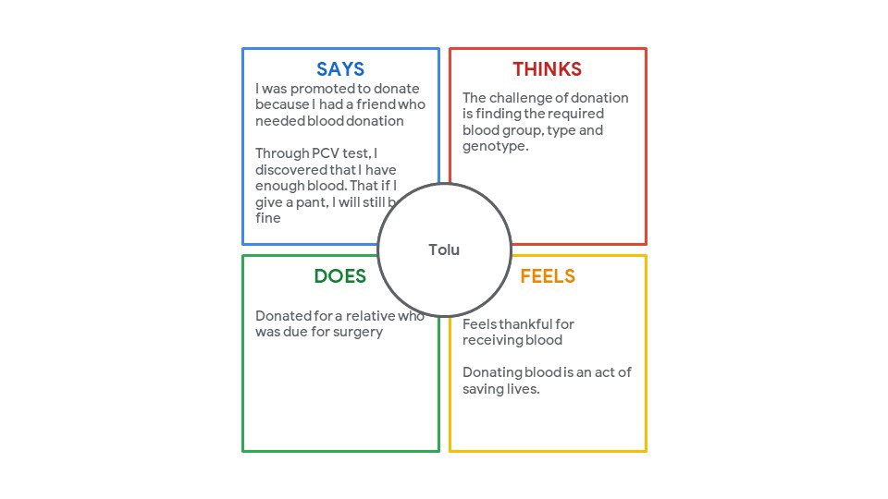



An empathy map was needed majorly for two reasons:

1. To align the team members on a single understanding of the user, their needs and motivations.
2. To identify key insights.

**Insights**:  
On analysing the empathy map we discovered some new insights:

* Donors are scared about their safety on returning back to the hospital.
* People want to secure a plasma donor for themselves in advance in case of any emergency.
* Most of them are ready to donate but don’t have much knowledge about the therapy.

**User Personas**

After analysing the empathy map and the insights carefully, I created user personas and divided the users into two main categories:

1. Seekers (Relatives of the patients seeking a plasma donor)
2. Donors (People who are ready to donate their plasma)

**Ideation:**

Plasma Donor Application is a blood donation app that connects potential donors to patients in need of blood. It makes reaching out to potential donors simple and helps people to become voluntary donors. In addition, donors can track the impact of their donations and create awareness around blood donation.

Every human being requires blood; hence it is essential to all human life and the world over. This seems obvious because blood constitutes approximately 8 percent of body weight, and the average male’s volume is between 5 -6 litres, and in the average female is between 4–5 litres.

A donor who wants to donate plasma can simply upload their recovered medical certificate and can donate the plasma to a blood bank. The blood bank after checking the donor certificate can make a request to the donor when the donor accepts the request, they can add the required number of units they need. The hospital can send a request to the blood bank that needs the patient's emergency plasma and to get the plasma from the blood bank.

The Planned system consists of the subsequent modules:

* Android Application: This component is used to maintain feasibility of the user. By using this component user can able to easily access the data related to the path labs, hospitals, tests, etc. It provides user interface and increases the portability of the user.
* Cloud: This is the second component of three tier architecture. It includes server and Database and handles them in cloud. Server plays the main role in the overall system as the whole authentication is done by server only and it also include the whole database.
* Client Portal: It is the third component of three tier architecture. As the system is able to provide the path labs then the client portal helps to register themselves with the system.

**Application Overview:**

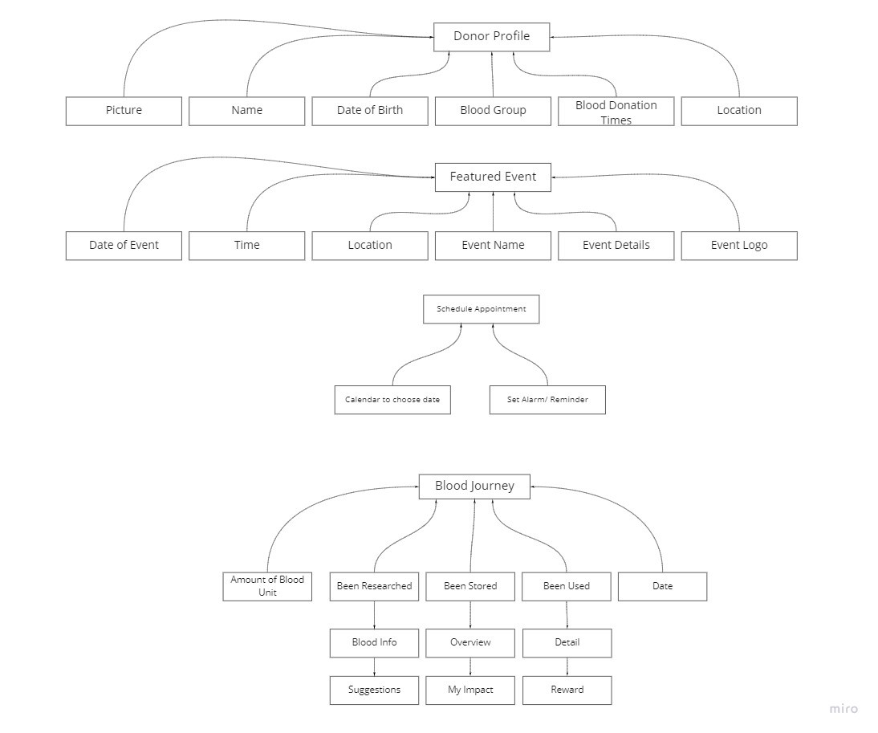

**Flow Diagram:**

